Technical Report:

Data exploration

The data set used for training and validating the algorithms includes information collected from December 6, 2005 (orbit 2438), to January 27, 2021 (orbit 21578). It consists of 2 083 317 entries, corresponding to samples of past observations, and 25 columns describing several observation features, as detailed below:

 | 1 | Ephemeris Time
 | 2 | Local True solar Time
 | 3 | Orbit number
 | 4 | Frequency
 | 5 | Band
Marsis position | 6 | Altitude
 | 7 | X coordinate
 | 8 | Y coordinate
 | 9 | Latitude
 | 10 | Longitude
Marsis antennas characteristics | 11 | Dipole Tilt
 | 12 | Monopole Tilt
Sun perspective | 13 | Solar Longitude
 | 14 | Mars Sun Distance
 | 15 | Sun Elevation Angle
 | 16 | F10_7 index
Magnetic Field | 17 | Tangential Magnetic Field
 | 18 | Total Magnetic Field
 | 19 | Radial Magnetic Field
Topography | 20 | Roughness
 | 21 | Slope
SNR | 22 | Median Corrected Echo Power
 | 23 | Peak Corrected Echo Power
 | 24 | Peak Distorted Echo Power
 | 25 | Peak Simulated Echo Power

Several analyses were performed on the data to highlight their characteristics. The first analysis performed concerned the noise of the received signal. In fact, this quantity is generally used to correct the real value of the received peak. The noise should be linked to a series of environmental factors that disturb the reception of the signal, first of all the ionosphere. The noise was represented with the median of the distorted echo (column 22).
From the analysis performed it is evident that the median is not correlated to environmental factors, but has a very evident dependence on the corrected peak of the signal, as shown in figure 1. This leads to the conclusion that this parameter is only a result of instrumental effects, therefore it is not suitable for characterizing the performance of an observation, which will therefore be evaluated for the moment only as a function of the peak. Finally, it was decided to proceed with the distorted peak and not the corrected one, since the former contains information on the effects of the ionosphere on the observation.

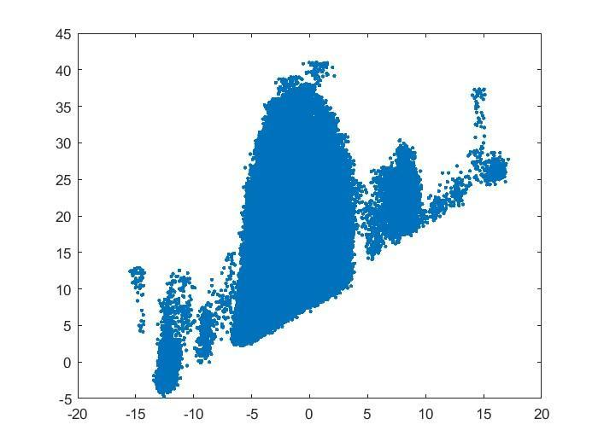
Figure 1: Median corrected echo power (22) vs Peak corrected echo power (23)

The relationship between the simulated peak, obtained by reconstructing the physical effects on the transmitted signal, and three factors that are considered to be among the most relevant for signal distortion: height, roughness and height of the sun, was also studied. The first analysis, highlighted in figure 2, shows the decreasing linear correlation between the signal peak and altitude (the dispersion could depend on the roughness). The simulated peak and the corrected real one were then corrected for the height, subtracting the curve that "fits" the simulated peak-height graph (figure 3).
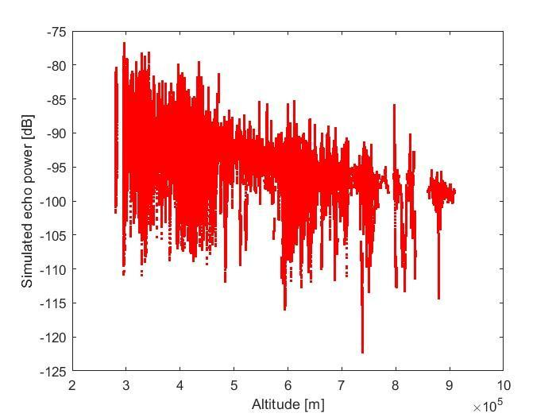
Figure 2: Peak simulated echo power (25) vs Altitude (6)
After the correction (and having subtracted the median) we see that the real peaks are much more dispersed than the simulated ones, surely because there are environmental factors that influence them (e.g. ionosphere) (figure 4).

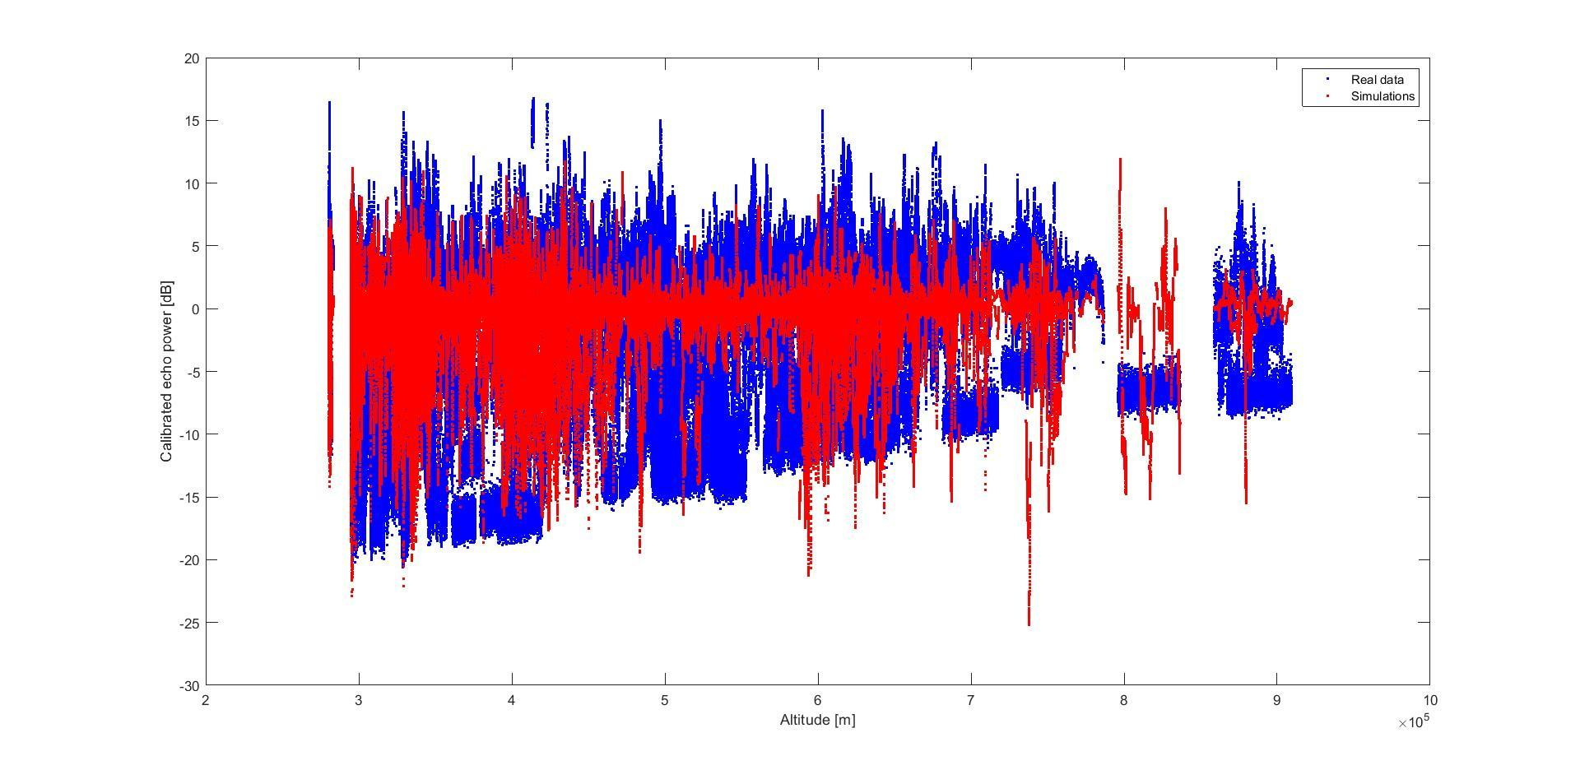
Figure 4: Peak corrected (blue) and simulated (red) after altitude correction
The correlation between the simulated peak and roughness was then studied, noting how, as the roughness increases, the dispersion increases and there is a decay in power.
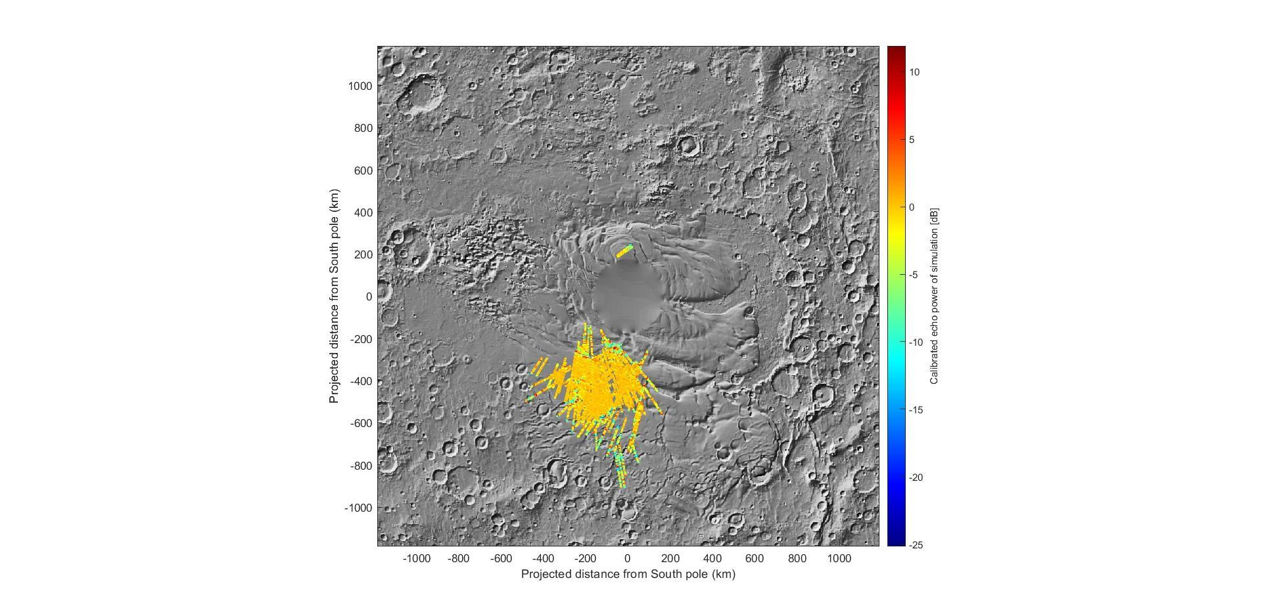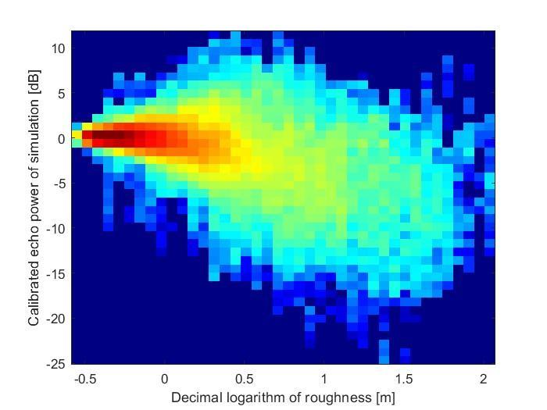
Finally, the analyses highlighted a negative correlation between signal peak and sun elevation.
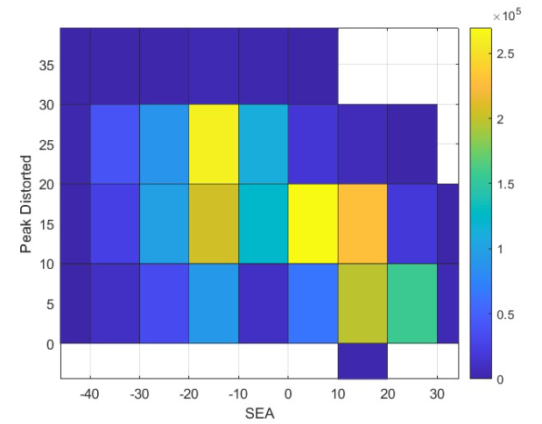

Data pre-processing
The data set that we used for training and evaluation was first of all cleaned of spurious patterns. In particular, we removed the records of the observations in which instrumental malfunctions happened or extraordinary solar activity was visible, thus reducing the dataset to 1 905 841 samples (corresponding to a 8.5% reduction). Ordinal features like orbit number and ephemeris time were not considered, and standardization was performed for the scale-sensitive algorithms. Column F10_7_index was ignored as that information is not known apriori for future observations.

